Secure messaging with zero knowledge proof and intelligent threat detection

MOHAMMAD AZRI BIN AZIZ
52215123264

Report Submitted to Fulfill the Partial Requirements
For the Bachelor of Information Technology (Hons.) in Computer System Security Universiti Kuala Lumpur

October 2025

DECLARATION

I declare that this repost is my original work and all references have been cited adequately as required by the University

Date: 22/01/2026 | Signature  Full Name:  ID Number: |   ......................................  MOHAMMAD AZRI BIN AZIZ  52215123264

APPROVAL PAGE

We have supervised and examined this report and verify that it meets the program and University’s requirements for the Bachelor in Computer System Security

Date: 22/01/2026 | Signature  Supervisor: Official Stamp: | ......................................  DR DELINA BEH MEI YIN
Date: 22/01/2026 | Signature  Accessor 1:  Official Stamp:  (Optional) | ......................................  PROF. DR. MEGAT FAREEZ AZRIL ZUHAIRI

Table Of Content

CHAPTER 1 7
INTRODUCTION 7
1.1 Introduction 7
1.2 Background of the Study 8
1.3 Problem Statement 10
1.4 Objectives 11
1.5 Project Scope 13
1.6 Significant of The Projects 15
1.7 Organization of the Report 17
CHAPTER 2 19
LITERATURE REVIEW 19
2.1 Introduction 19
2.2 Overview of Secure Enterprise Messaging 20
2.3 Zero Knowledge Proofs (Authentication) 20
2.3.1 Privacy Preserving Authentication 20
2.3.2 Feasibility on Resource-Constrained Devices 21
2.3.3 Application in Identity and Data Integrity 22
2.4 End-to-End Encryption (E2EE) Protocols 23
2.4.1 Vulnerabilities in Authentication Ceremonies 23
2.4.2 The Insider Threat Landscape 23
2.4.3 Architecture and Scalability 24
2.5 On-Device AI Anomaly Detection 25
2.5.1 The Shift to Edge Computing 25
2.5.2 Mobile Optimization Techniques 25
2.6 Summary and Research Gap 26
2.7 Conclusion 27
CHAPTER 3 28
METHODOLOGY 28
3.1 Introduction 28
3.2 Overview of Software Development Models 29
3.2.1 Waterfall Model 29
3.2.2 Agile Model 30
3.2.3 Rapid Application Development (RAD) 31
3.3 Proposed Methodology 32
Justification for Choosing RAD 32
3.4 Phases of Development 34
3.4.1 Phase 1: Requirements Planning 34
3.4.2 Phase 2: User Design 34
3.4.3 Phase 3: Construction 40
3.4.4 Phase 4: Cutover 41
Integration Testing: 41
Security Audits: 41
User Acceptance Testing (UAT): 41
3.5 System Requirements 42
3.5.1 Hardware Requirements 42
3.5.2 Software Requirements 43
3.5.3 Budget and Costing 44
3.6 Project Planning 45
Gantt Chart Link: Excel_File_Link 45
3.7 Chapter Summary 46
REFERENCES 47

LIST OF FIGURES
Figure 2.3.1.1: Zero-Knowledge Proof Sequence Diagram ............................................. 21
Figure 3.2.1.1: Diagram Waterfall Model ...................................................................... 29
Figure 3.2.2.1: Diagram Agile Model ............................................................................ 30
Figure 3.2.3.1: Diagram Rapid Application Development (RAD) Model .......................... 31
Figure 3.4.2.1: SentriZK System Architecture .............................................................. 35
Figure 3.4.2.2: SentriZK Sequence Diagram ................................................................ 36
Figure 3.4.2.3: SentriZK SentriZK Flow chart................................................................ 37
Figure 3.4.2.4: SentriZK Use Case Diagram ................................................................. 38
Figure 3.4.2.5: SentriZK Misuse Case Diagram ............................................................ 39
Figure 3.6.1: Project Gantt Chart Summary ................................................................. 47

List of Tables
Table 3.5.3.1: Project Cost Breakdown ....................................................................... 44

CHAPTER 1

INTRODUCTION

1.1 Introduction

Security of private messaging apps poses a major hurdle in today's workplace talk. Firms, particularly smaller ones lean on software such as Slack or Teams to stay connected throughout the day. Yet those services usually save login details on shared digital hubs, turning them into easy spots for hackers to strike. When a main database gets compromised, intruders might take password hashes or access keys, letting them pretend to be workers while gaining entry to private information. Instead of just forcing passwords, hackers now often steal entire sessions, just like we saw in big leaks lately.

Nowadays, inside risks along with malware spreading become more common issues. Even though E2EE guards data during transport, security experts lose visibility. Scanners used on regular servers fail because they cannot access contents inside encrypted chats. That missing insight leaves defenses weakened. So someone on the inside, either acting badly or pressured, might pass dirty messages or downloads and those go right past what the server checks for.

To address these issues, this project introduces a secure communication framework. It combines Zero-Knowledge Proofs (ZKP) to authenticate users without sending passwords over the network, and on-device Artificial Intelligence (AI) to detect threats locally on the user's phone. This is the direction that this project is going. Its goal is to create a system that eliminates credential theft risks by verifying identity mathematically and uses lightweight AI to find anomalies without breaking user privacy. This project mainly looks at the integration of the Groth16 ZKP protocol and TensorFlow Lite models for identifying behavioral anomalies in a mobile environment.

1.2 Background of the Study

In messaging setups, logging in gets explored through various means. Passwords often sit in one main storage spot, hashed and salted for safety. Yet findings point out flaws that central spot can crash everything if it fails. Session tokens in wrong hands might slip past Multi-Factor Authentication, letting attackers see private messages inside companies (Threat modeling for enterprise secure messaging applications, 2025). A fresh look at security could start with Zero-Knowledge Proofs. Backed by research from 2024 into how logins get verified, using zk-SNARKs allows checks on who someone is without moving any personal details around. Rather than posting secrets out loud, a person might prove they know a password by demonstrating it without revealing the actual code to the server.

Anomaly detection in encrypted environments is also getting more attention these days. A lot of writing has been done on using Machine Learning (ML) to find threats. A systematic review of anomaly detection using machine and deep learning techniques (2022) highlights that Deep Learning outperforms standard ML on high-dimensional data but often requires significant bandwidth and processing power. Usually, this processing happens on a cloud server, which is not possible when messages are end-to-end encrypted.

Some research looks at things more generally by moving detection to the device’s edge or local level. Take AI-powered smishing spotting on Android phones - recent efforts like Tiny BERT (2025) and the PHILDER setup (2025) for low-end gadgets - they prove compact AI setups handle tasks well. Accuracy hits 96% or higher right there on the phone. That means less delay plus better control over personal data. Running things locally means stronger privacy and faster results. Still, nearly all current fixes aim at spotting fake texts or suspicious links instead of watching user actions live inside secure message chats.

Implications for this project:
The background shows that while ZKP and Edge AI are powerful individual technologies, they are rarely combined in SME messaging apps. Many existing systems either prioritize security (encryption) but lose visibility on threats or prioritize threat detection (server scanning) but compromise privacy. This project aims to build a clear, reproducible, secure messaging pipeline using the Groth16 protocol for auth and on-device TensorFlow Lite for detection, following the Rapid Application Development (RAD) methodology.

1.3 Problem Statement

Although many platforms use encryption and MFA, several important problems remain when we look at securing internal communications for SMEs. These problems are:

- Centralized credential storage acts as a single point of failure.
Some companies use systems that hold hashed login details locally. Take what happened with Slack in 2023 - hackers used stolen tokens or exposed info inside company databases, letting them read work chats. Stored secrets, even with extra login steps, leave gaps when breaches occur (Threat modeling for enterprise secure messaging applications, 2025). This project tackles that issue using Zero-Knowledge Proof authentication - the server keeps no passwords, just math-based commitments that leave intruders empty-handed

- End-to-End Encryption creates a "blind spot" for threat detection.
Even though scrambling messages shields them from outsiders, it also hides what servers can check for danger. Take 2025, attackers slipped harmful code through Discord invite links buried in everyday talk (AI-driven smishing detection in Android devices, 2025). Right now, there’s no live system spotting hidden risks or odd behavior since the machine never reads the actual words being sent. Local processing now handles detection, shifting tasks to the user's device through encrypted AI processing. Risk assessment occurs where data resides, skipping central hubs. Behavior analysis happens privately, maintaining control over sensitive information. Decryption is not required for insights, since evaluation takes place offline. Security stays intact because no cleartext data travels outside the endpoint. Performance improves since network traffic drops out of the loop. The shift keeps confidentiality without relying on optional trust platforms.

1.4 Objectives

The aim of this project is to develop a secure internal chat application for SMEs that integrates Zero-Knowledge Proof (ZKP) authentication and on-device AI anomaly detection to eliminate credential theft and detect insider threats without compromising user privacy.

The project is guided by the following objectives:
1. To study existing authentication and anomaly detection methods in internal messaging systems and identify their security limitations.
This involves investigating the security architecture of current End-to-End Encrypted (E2EE) platforms to understand why manual authentication ceremonies fail and how centralized credential storage creates single points of failure. Detailed research will be conducted on the mathematics of the Groth16 zk-SNARK protocol to understand how it allows for password-less verification. Furthermore, the study will analyze different Machine Learning architectures, specifically comparing Cloud-based detection versus Edge AI (On-Device) methods. This is crucial to identify how heavy models like Isolation Forests can be optimized for mobile processors (TensorFlow Lite) to detect behavioral anomalies such as phishing links or unusual login times without sending private data to a central server.

2. To develop a secure internal chat application integrating Zero-Knowledge Proof authentication and on-device AI anomaly detection.
This means building a "Privacy-First" ecosystem through engineering, done via Rapid Application Development (RAD). Writing happens alongside custom cryptographic circuits built with Circom - proof creation runs on clients’ devices. Because of this setup, no passwords exit the user’s gadget during login attempts. At the same time, another task unfolds: teaching a TensorFlow Lite model until it fits within a Flutter mobile app. That model runs under its own logic, baked into the app’s structure. In operation, the system picks up user input as it happens, breaking down message details to work out a risk level on the fly - all without touching the AES-256 lock that guards data exchange. Real-time processing feeds into how tokens are split apart, keeping things local yet accurate.

3. To test the System Functionality and Security Level effectiveness.
This involves conducting a series of performance and security tests to benchmark the system against standard metrics. The testing phase will focus on three key areas: Authentication Latency, measuring the time required to generate and verify ZKP proofs on standard mobile hardware; Detection Accuracy, using datasets of known social engineering attacks to verify if the on-device AI correctly flags malicious content with minimal false positives; and Privacy Auditing, ensuring that even during a simulated server breach, no usable credentials or plaintext messages can be extracted from the database.

1.5 Project Scope

This work focuses on building a secure communication solution suited for workplace use. Its coverage includes several main concerns.

Target users: People using this project fall into employees and high level decision makers working in Small and Medium Enterprises where private business information is handled often. Roles here include finance staff, human resources leaders, system administrators responsible for digital infrastructure inside companies all needing tight data protection. Security becomes easier when tools work well without demanding advanced tech knowledge. Because team members bring different skill levels, the goal sits just beneath surface: safety must not slow daily work or make it harder to use.

Functions and features of the system: At its center, the tool handles key security tasks while protecting personal details. It begins with Zero-Knowledge Proof authentication users prove who they are without sending their password across networks. Instead of storing or holding login data, the process uses mathematical checks run entirely offline. Built around Groth16 methodology, these local computations create evidence the system can verify. Should a breach occur on the hosted side, attackers gain nothing from it. Proof exists, but nothing identifiable gets recorded (Groth16, client-side proof generation).

On top of locked-down access, the tool runs local AI checks for odd behavior. Rather than forwarding data to a remote server, it uses a built in TensorFlow Lite framework to examine what users type in and messages they send, moment by moment. Watched signs include odd URLs, mismatched typing rhythms, or times when signing in feels off. Decisions happen right there, not after sending signals overseas. Looking closely at these elements where they’re used helps spot risky behavior like hackers pretending to be coworkers even before data gets locked up.

User interface and experience: One way the system works is by using a Flutter-based interface. Because of this, people find it straightforward to move around inside the app. Handling encryption keys becomes simpler too. Security notifications stay within reach without requiring complex tech understanding. A live threat signal shows up clearly on screen. When danger approaches, a red banner appears right away. The artificial intelligence flags risky behavior just in time. This visual cue helps users choose wisely when deciding to share private information.

Implementation platform and development environment: Development environment and tools The project will be developed primarily for Android mobile devices, utilizing Visual Studio Code and Android Studio as the primary Integrated Development Environments (IDEs). Built on Node.js, the backend verification service manages ZKP proofs circom handles cryptographic circuit creation. Performance adjustments focus on mobile hardware, particularly processors, to maintain smooth operation without excessive power use. Math-intensive tasks like AI and zero knowledge proofs stay efficient on everyday phones.

Security elements in the system: Security is integrated through Zero Knowledge Proof authentication and local artificial intelligence processing. Zero Knowledge Proofs ensure identity verification without transmitting or storing passwords, while Groth16 client-side proof generation prevents sensitive data exposure even during server-side breaches. Local AI analysis using TensorFlow Lite allows real-time detection of abnormal behavior without sending user data to external servers.

1.6 Significant of The Projects

The significance of this study comes from the urgent need to solve the conflict between user privacy and system security. In the current digital landscape, Small and Medium Enterprises (SMEs) are often forced to choose either they encrypt everything and lose the ability to spot insider threats, or they monitor everything and violate user privacy. This project is significant because it proposes a third option, using mathematics and local AI to achieve both at the same time.

This study contributes to the field and benefits stakeholders in three specific ways:
1. Eliminates the risk of credential theft. One of the biggest issues in cybersecurity today is that servers hold too much sensitive data. If a database is hacked, passwords even hashed ones are at risk. This project is significant because it proves that authentication can happen without the server ever knowing the user's password. By implementing Zero-Knowledge Proofs (ZKP), this study provides a working blueprint for "password less" security. It shows developers that it is possible to verify a user’s identity mathematically, meaning that even if the server is breached, there are no credentials for attackers to steal.

2. Demonstrates privacy-preserving threat detection. Currently, most "insider threat" detection tools require reading the messages employees send, which creates privacy concerns and compliance issues with laws like the PDPA or GDPR. This project is significant because it shifts the detection logic to the "Edge" (the user's phone). It demonstrates to business owners and security officers that they can detect malicious behavior like someone sending phishing links without ever decrypting private chat. This helps organizations maintain strict security standards while respecting the privacy rights of their staff.

3. Benchmarks High-Grade Security on Resource-Limited Hardware. There is a common belief that heavy cryptographic protocols like zk-SNARKs and AI models are too slow for standard mobile phones. This study challenges that assumption. By optimizing these technologies to run on a standard Android device, this project provides valuable data to the academic community regarding the limits of mobile hardware. It serves as a benchmark for future researchers, proving that consumer grade devices are now powerful enough to handle enterprise-grade encryption and AI inference simultaneously without ruining the user experience.

1.7 Organization of the Report

This dissertation is structured into five chapters that logically detail the research, design, development, and evaluation of the SentriZK project. The following chapters describe the progression from theoretical research to the final working system:
- Chapter 2 Literature Review: This chapter sets up the thinking behind the work. It looks at past studies across three areas: Zero-Knowledge Proofs, how messages stay locked down, and AI that runs on devices. Because today's main messaging platforms collect too much data, the section shows where they fall short. One major gap stands out - keeping watch for security risks while still protecting personal privacy. That open need is exactly what the effort sets out to tackle.

- Chapter 3 Methodology: This chapter explains how the main goal of the project was achieved through a clear method. Instead of just listing tools, it shows why RAD was chosen for building the system. You will find drawings that map out how parts connect within the tech framework. Hidden details about privacy protection appear alongside schematics showing data flow paths. Because this lays down practical steps, others can replicate key functions safely. What matters is now someone else needs only refer to these pages to replicate exact builds without guessing.

- Chapter 4 System Development: This chapter shows what happened when the software was made. First comes setup, where choices were made and tools added via plugins. After that, stages unfold - bits of code appear along with early functions - for Version 1, then adjustments pile into Version 2. Each change builds on the last, revealing progress through doing.

- Chapter 5 Result and Findings: This chapter looks at whether the system really functions as intended. Various testing methods come into play checking how it works, ensuring security holds up, plus making sure real users agree it meets the needs. Each test runs certain scenarios by design; outcomes appear clearly here, showing the system is both safe and on track with what was planned.

- Chapter 6 Conclusions: This last section ties everything together. Thoughts gather here about what stood out during the journey. How things unfolded gets examined closely. Each goal laid out in Chapter 1 now shows clear signs of being met. The reasons behind certain outcomes are worth noting take center stage. It also recognizes what the existing setup can’t do well. Future growth plans are laid out clearly here too.

CHAPTER 2

LITERATURE REVIEW

2.1 Introduction

This chapter reviews the existing body of knowledge regarding secure communication systems, cryptographic authentication, and mobile anomaly detection. A fresh look at today’s tools begins here sorting them into three areas tied directly to what the project runs on. Each part holds weight because it connects straight to how things work together. What works well shows up just as clearly as what falls short. This split helps make sense of where effort should go next without losing sight of the bigger picture.

- Zero Knowledge Proofs (Authentication): An evaluation of privacy-preserving protocols that eliminate the need for password transmission.
- End-to-End Encryption (E2EE) Protocols: An analysis of current secure messaging standards, focusing on authentication vulnerabilities, scalability, and the detection of insider threats.
- On-Device AI Anomaly Detection: A review of machine learning techniques optimized for resource-constrained mobile environments to detect malicious behavior locally.

The chapter concludes by synthesizing these domains to identify specific research gaps, highlighting the lack of integrated solutions in the current landscape.

2.2 Overview of Secure Enterprise Messaging

Looking at tech tools first doesn’t mean we skip what secure messaging in businesses really means. These tools help teams talk inside work environments keeping messages private, trustworthy, and always reachable. Not just any setup fits large organizations; each one built right tackles espionage risks head on. Rules like legal mandates shape how these systems behave across company networks.

What marks today’s protected messaging? It’s called End-to-End Encryption. Keys sit entirely on the user’s phone or tablet. Data gets locked while sending, stays locked during transit. Only unlocks when it reaches the other person. Nobody in between not carriers, not servers sees the real message. Even though E2EE strongly guards against outside eavesdropping, research shows it struggles with checking who uses the system and spotting risks from within.

2.3 Zero Knowledge Proofs (Authentication)

To address the inherent risks of transmitting passwords or credentials over a network, researchers have extensively investigated Zero Knowledge Proofs (ZKPs). These cryptographic protocols allow a "prover" to demonstrate knowledge of a secret to a "verifier" without ever revealing the secret itself.

2.3.1 Privacy Preserving Authentication
One big reason people are moving away from old-style logins? They want to leave out hidden keys nobody should hold. Take a look at what Bhattacharya and team noticed no shared secrets mean less exposure. In their 2024 paper titled "Enhancing Digital Privacy: The Application of Zero Knowledge Proofs in Authentication Systems," they compared password scrambling methods with zero knowledge proof setups. What stood out: zero knowledge systems send no identifying data through the process. That difference alone makes privacy stronger. One thing stands out zk-SNARKs run fast, with compact proofs. Yet here comes zk-STARK, built tough against quantum attacks, just heavier in size. Even though zk-SNARKs zip through transactions quickly, getting them set up feels sticky. So, the idea lingers: speed vs scale, still unsure who moves first.
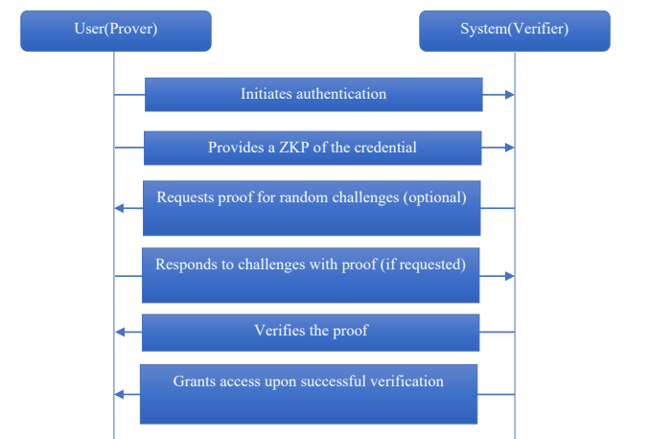
Fig. 2.3.1.1 Zero-Knowledge Proof Sequence Diagram

2.3.2 Feasibility on Resource-Constrained Devices
A primary concern in the literature is whether mobile devices possess the computational power required for ZKP operations. A 2023 study, "A Survey on Zero-Knowledge Authentication for Internet of Things," addressed this by comparing various ZKP schemes on hardware with limited battery and processing power. The survey concluded that Non-Interactive Zero-Knowledge Proofs (NI-ZKP), specifically the Groth16 protocol, are highly efficient due to their minimal proof size. This validates that protocols originally designed for IoT sensors are computationally feasible for modern smartphones.

2.3.3 Application in Identity and Data Integrity
Beyond just logging in, zero-knowledge proofs help manage identities in more meaningful ways. A 2023 study called “Privacy Preserving Identity Management System on Blockchain Using zk-SNARK” showed how zk-SNARKs could work on Ethereum to create decentralized identity systems. It let people prove who they are while keeping private details off record. Still, heavy gas expenses slowed things down when moving transactions through the network. Scalability took a hit because of those charges piling up.
Similarly, a 2025 study titled "A Secure Framework for Privacy-Preserving Analytics in Healthcare Records" utilized ZKP to verify sensitive medical data without exposing patient records. This demonstrated the concept of "Auditability without Visibility”proving that a system can verify a user's authorization status or data validity without ever viewing the underlying sensitive information.

2.4 End-to-End Encryption (E2EE) Protocols

While ZKP addresses authentication privacy, the integrity of the messaging channel itself relies on End-to-End Encryption protocols. Current literature highlights that while the encryption mathematics are sound, the implementation and surrounding processes are vulnerable.

2.4.1 Vulnerabilities in Authentication Ceremonies
A significant weakness in E2EE systems is the method used to verify that encryption keys belong to the intended user. Alatawi and Saxena (2023), in "SoK: An Analysis of End-to-End Encryption and Authentication Ceremonies," analyzed 17 popular messaging applications. They found that while "opportunistic" encryption protects against passive eavesdropping, it fails against active Man-in-the-Middle (MitM) attacks because users neglect manual "Authentication Ceremonies" (e.g., scanning QR codes). The study identified human error in verifying long hexadecimal strings as a critical vulnerability, suggesting that manual verification is functionally broken.

2.4.2 The Insider Threat Landscape
Encryption creates a "blind spot" for monitoring malicious activity originating from authorized users. In "Insider Threat Detection and Secure Data Transfer Leveraging Bidirectional LSTM" (2025), researchers proposed using Bidirectional Long Short Term Memory (Bi-LSTM) networks to analyze user behavior patterns. They found that analyzing the sequence of actions (forward and backward in time) provided higher accuracy in detecting insiders than looking at isolated events.
Still, researchers looked at a 2024 study called "A Review of Recent Advances in Malicious Insider Threat Detection." Though deep learning works okay with big data sets, it has drawbacks according to that piece. One issue stands out: results often lack clear reasoning because systems cannot easily show what they notice. Another problem comes up when some parts of a dataset get very little attention. In insider attack scenarios, real incidents appear infrequently much less than everyday network activity. That gap makes prediction even harder under real-world conditions.

2.4.3 Architecture and Scalability
The underlying architecture of E2EE systems is also a subject of active research. In "Threat Modeling for Enterprise Secure Messaging Applications" (2025), authors used STRIDE threat modeling to identify that while the network layer is encrypted, endpoints remain vulnerable to metadata analysis and session hijacking. Additionally, practical implementation remains complex; a 2025 study on "Implementation of Secure E2EE Chat Application in Microservice Architecture" demonstrated a framework using AES-256 and Diffie-Hellman but relied on standard architectures that do not account for post-quantum threats.
Still, handling growth isn’t easy. According to Barnes and team in 2023, the security setup for messaging - called MLS Protocol follows old patterns seen in older systems such as the Double Ratchet method, where size matters: performance slows down in big circles because it depends on numbers straight up (O(n)). A fresh take called TreeKEM steps in, building on a tree like structure instead of chains; this shift cuts the effort needed to reencrypt data way down to nearly manageable levels (O(log n)). Turns out, end-to-end crypto doesn’t have to shrink when things get busy if we update how we build it.

2.5 On-Device AI Anomaly Detection

The final domain reviewed concerns the detection of the insider threats mentioned in Section 2.4 without compromising the privacy guarantees of E2EE. This requires moving analysis from the cloud to the device (Edge AI).

2.5.1 The Shift to Edge Computing
Natha et al. (2022), in "A Systematic Review of Anomaly detection using Machine and Deep Learning Techniques," highlighted that traditional Machine Learning (like SVM) often underfits complex real-world data, necessitating Deep Learning. Traditionally, Deep Learning required cloud resources, which poses privacy risks.
However, recent advancements have made on-device detection viable. The paper "PHILDER: Lightweight Framework for Intelligent Phishing Detection on Resource-Limited Devices" (2025) demonstrated a compressed Deep Learning model running on ARM-based mobile processors. The researchers achieved over 90% accuracy in detecting threats with less than 100ms latency, proving that heavy cloud servers are not strictly necessary for effective detection.

2.5.2 Mobile Optimization Techniques
Supporting this shift, Gaurav et al. (2025) presented "AI-Driven Smishing Detection in Android Devices Using TinyBERT." By utilizing a TinyBERT transformer model optimized for Android, they achieved 96.81% accuracy, significantly outperforming traditional models like Random Forest. This validates that complex transformer models can be distilled for mobile use.
Furthermore, a 2023 study on "Phishing Detection System Through Hybrid Machine Learning" explored combining algorithms. Their hybrid approach showed that combining "shallow" learning (Random Forest) with "deep" learning features allowed for better extraction of lexical patterns (such as URL length or character randomness) than using a single model alone.

2.6 Summary and Research Gap

The review of existing literature reveals specific strengths in individual technologies but a distinct gap in their integration for SME communication tools.
Summary of Existing Literature:
- Authentication: One issue is checking identities studies show basic E2EE checks often collapse (Alatawi & Saxena, 2023). Though zero knowledge proofs help solve this (Bhattacharya et al., 2024), those methods work more in blockchain or iot setups than everyday messaging tools.
- Encryption & Threats: Though E2EE shields against outside risks, firms lose sight of bad actors already inside. For spotting such behavior, Deep Learning - especially Bi-LSTM methods - works well. Yet nearly all answers depend on analyzing traffic across networks, a move that undoes E2EE's private design.
- Detection: Mobile AI, such as TinyBERT or PHILDER works well for certain jobs, say spotting SMS scams, yet few studies look at using similar tools inside devices to watch how people behave privately online, right as they happen.

Identified Gap: A missing piece remains are no single approach links Zero Knowledge Proofs to on-device AI for spotting unusual user behavior without compromising security. Right now, picking one means choosing between obscurity and insight: protecting information hides risks, while lifting restrictions exposes personal details. A missing piece remains no single approach links Zero-Knowledge Proofs to on-device AI for spotting unusual user behavior without compromising security. Right now, picking one means choosing between obscurity and insight: protecting information hides risks, while lifting restrictions exposes personal details.

2.7 Conclusion
This chapter has presented a critical review of the existing literature related to secure messaging, cryptographic authentication, and mobile anomaly detection. One finding stood out clearly existing E2EE systems depend too heavily on users confirming identities by hand, leaving gaps. Another point emerged: Zero Knowledge Proofs could solve privacy issues during login, yet few messaging apps actually use them. Surprisingly, newer tools in Edge AI now allow powerful threat analysis to operate right inside smartphones. The review confirms that while the individual technologies required to secure SME communications exist, they lack unified integration. The research gaps identified in this chapter specifically the absence of automated trust verification and local behavioral monitoring serve as the primary motivation for this project. These theoretical findings will guide the system design and development approach, which are detailed in the following chapter, Chapter 3: Methodology.

CHAPTER 3

METHODOLOGY

3.1 Introduction

This chapter explains the methodology and the steps taken to develop the SentriZK project and also aims to outline the method behind building, testing, and launching a secure messaging tool. Starting off, it surveys various ways to develop software, explaining why Rapid Application Development stood out as the best fit for this effort.
Following that, the document outlines what happens during every stage of building the system like collecting user needs and creating early versions of the interface. Instead of just listing tasks, it goes deeper into how the platform will be structured from bottom to top. You see visual representations: a map of system components, step-by-step processes, interactive workflows, a guide on navigation paths, along with safeguards against potential weaknesses. Each drawing serves a purpose in making data protection clear and predictable throughout the experience. Moving on, the section covers what equipment and programs need using, along with funding details and a timeline for work steps so everything wraps up when expected. Exactly which tools get used during setup appear here too.

3.2 Overview of Software Development Models

A way to build software lives hidden inside different methods. Picking the right one shapes who gets heard during planning, how layouts take form, when checks happen. This effort looked closely at three paths - Waterfall, Agile, plus a fast version named RAD - to see which fits best. Each path moves development down separate roads. Decisions based on them steer outcomes. Not all work the same once project gets bigger

3.2.1 Waterfall Model
Back in the early days of coding, this method stood out as clear and step-by-step. Instead of loops or stages mixed together, it breaks work into rigid chunks - first figure out needs, then map them logically, after that write code piece by piece. Following that path comes checking for bugs, followed later by release and ongoing fixes whenever issues arise. Each stage wait for its turn before moving forward.
Finish one stage only after getting official permission, then proceed to what comes next. Clear written records matter a lot under this approach - writing down system needs early on sets them firm right at the start.
- Strengths: It keeps things simple through strict stages. When project needs stay clear and unchanged, this approach works well without extra hassle.
- Weaknesses: this method doesn’t adapt well. Once work moves past the testing phase, shifting things becomes tough and expensive. Because of that rigidity, using it feels risky when user needs keep altering. Projects with changing demands might not be the best fit here.
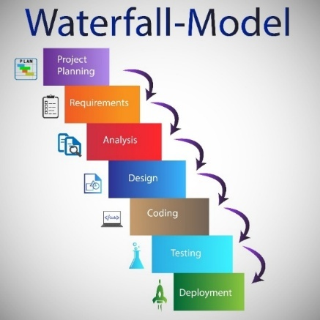

Fig. 3.2.1.1 Diagram Waterfall

3.2.2 Agile Model
Starting differently than the traditional Waterfall method, the Agile approach works through repeated small steps. Instead of delivering everything at once, it breaks work into short cycles often called sprints - for easier tracking and adjustments. Change happens often here because adaptability is built into the process, not forced. Working together matters just as much as meeting user needs on time, since detailed plans are less required at the start.
Change happens often in Agile, because it learns fast. Testing never stops here, woven right into how things grow. Feedback slips in regularly, shaping each step after use shows what works. The result? A system that shifts smoothly when life gets unpredictable.
- Strengths: The Agile model is highly flexible and responsive to changing requirements, with continuous testing helping to identify and resolve issues at an early stage.
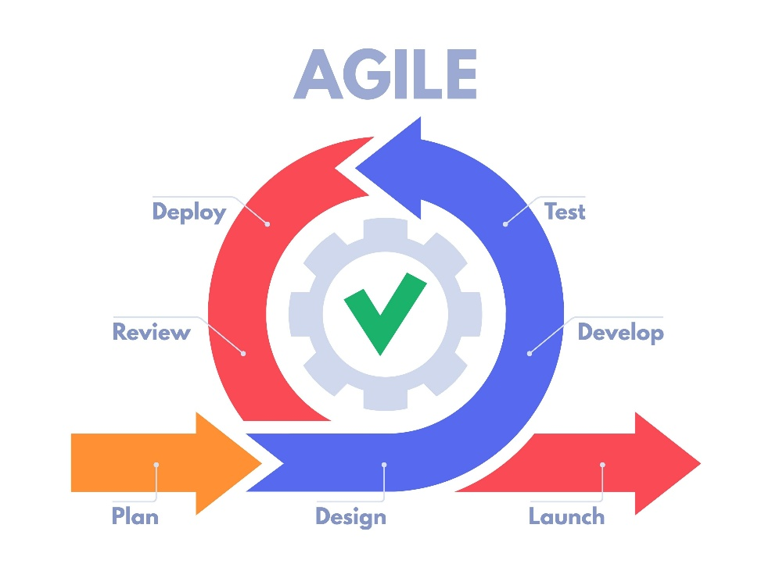
- Weaknesses: Keeping users involved regularly tends to consume steady amounts of effort and personnel. Should oversight lapses, project boundaries might grow beyond intent, possibly slowing things down later.
Fig. 3.2.2.1 Diagram Agile Model

3.2.3 Rapid Application Development (RAD)
In rapid application development, quick prototypes take center stage alongside constant input from users instead of long term blueprints. Instead of breaking work into separate stages like typical methods do, RAD packs analysis, planning, building, and checking together in rapid loops. Each loop delivers working pieces faster than traditional steps would allow.
Right off, one thing stands out in RAD: working samples appear fast. These rough versions get shown to users or managers before long. Feedback comes back quickly, shaping changes that keep moving forward.
- Strengths: With RAD, systems come together fast timelines shrink quickly. Because it lets people see the app sooner, there’s better alignment with what users actually need.
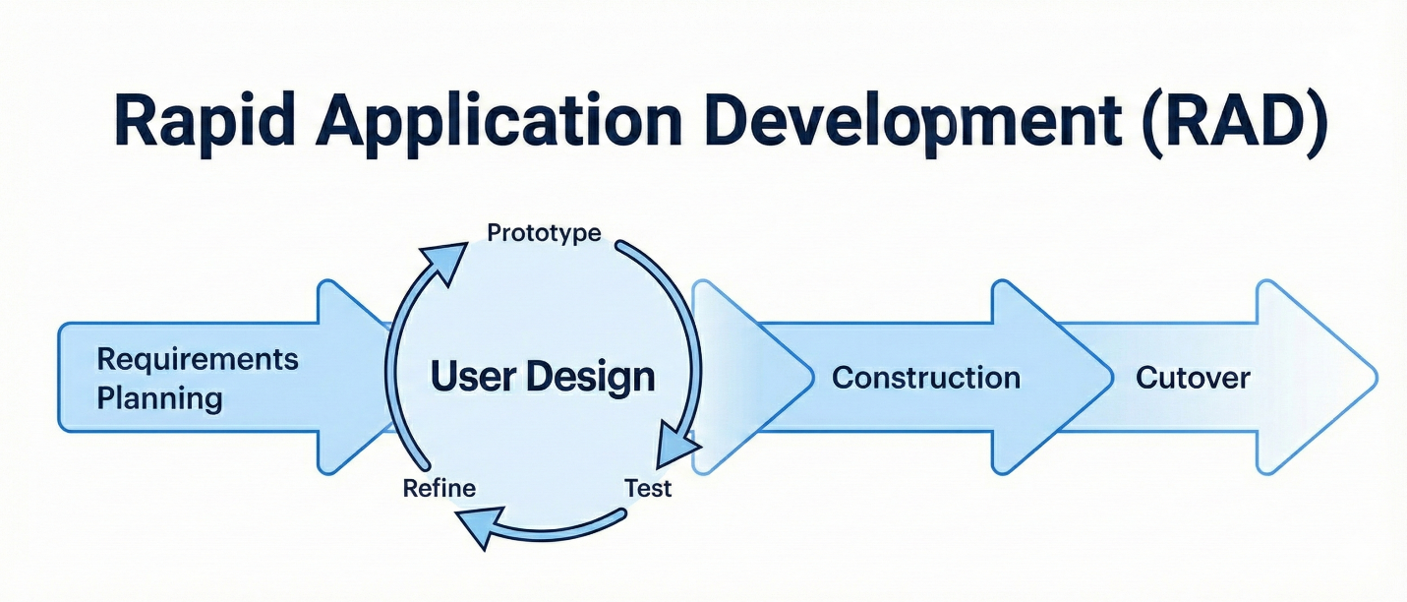
- Weaknesses: One issue with RAD is how it demands modules built separately, something tricky in certain work settings. Yet when deadlines loom close say, near the end of a student's last semester its fast pace and early testing loops become surprisingly useful.

Fig. 3.2.3.1 Diagram Agile Model

3.3 Proposed Methodology

After looking at different ways to develop software, as mentioned earlier, the choice landed on Rapid Application Development simply because it fits best here.
What made us pick RAD wasn’t just speed - it’s how fast you can build, then tweak. Instead of sticking to fixed steps, we leaned into making things quickly, over and over. For this work, splitting tasks into smaller chunks helped keep changes manageable. Testing pieces early came naturally here, since new ideas often pop up unexpectedly. Other methods might slow down when details shift - this one didn’t blink. From start to finish, we went through steps like defining needs, shaping layouts, building features, then switching to the new version.

Justification for Choosing RAD
That choice stands because of these factors.
1. Requirement for Early Visualization (Prototyping)
Meeting user needs often proves tough in coding work. In RAD, quick mock-ups come first - showing working versions to team leaders and clients while things are still new. By seeing real demos soon, both shape and features get checked ahead of completion. Mistakes in understanding needs? They happen less because everyone sees how it actually works early.
2. Time pressures during the final year project
Finish this task by the end of the academic period - no exceptions. When problems show up late, like in testing, the usual step-by-step approach might fall behind. Instead, RAD moves fast using pre-built parts and overlapping tasks, making it possible to get a live setup up and running before time runs out.
3. Flexibility and Adaptability
Midway through building something, small shifts in what's needed can happen after checking things or hearing thoughts. Because RAD allows flexibility, adjustments fit smoothly into the work-in-progress stage - no major delays follow. Such freedom stands out when placed beside stiffer approaches like Waterfall.
4. Risk Mitigation
Breaking down the system into simpler parts helps spot problems sooner. Testing each piece on its own reveals hidden issues before they cause trouble. When something goes wrong in just one module, fixing it right away keeps other work moving forward. This way, delays happen less often across the entire effort.

3.4 Phases of Development

The development of SentriZK follows the Rapid Application Development (RAD) lifecycle. This approach was selected to allow for the parallel development of the three core modules: Zero-Knowledge Authentication, End-to-End Encryption (E2EE), and AI Anomaly Detection. The lifecycle consists of four distinct phases: Requirements Planning, User Design, Construction, and Cutover.

3.4.1 Phase 1: Requirements Planning
The primary objective was to define the integration points between security, privacy, and intelligence.
Data Collection & Scope Definition
- Stakeholder Consultation: Discussions with NISHA SUTERA ENTERPRISE highlighted the need for a system that not only secures login (Auth) but also protects trade secrets in transit (E2EE) and proactively filters malicious links (ML) without manual oversight.
- Dataset Acquisition (For ML): To train the Anomaly Detection module, public datasets containing phishing URLs and social engineering text patterns were gathered to train the TensorFlow Lite model.
- Cryptographic Standards Review: The Signal Protocol and ECDH (Elliptic Curve Diffie-Hellman) were analyzed to ensure the E2EE module meets industry standards alongside the ZKP implementation.

3.4.2 Phase 2: User Design
In this phase, the technical architecture was designed to ensure these three modules could coexist without performance degradation.

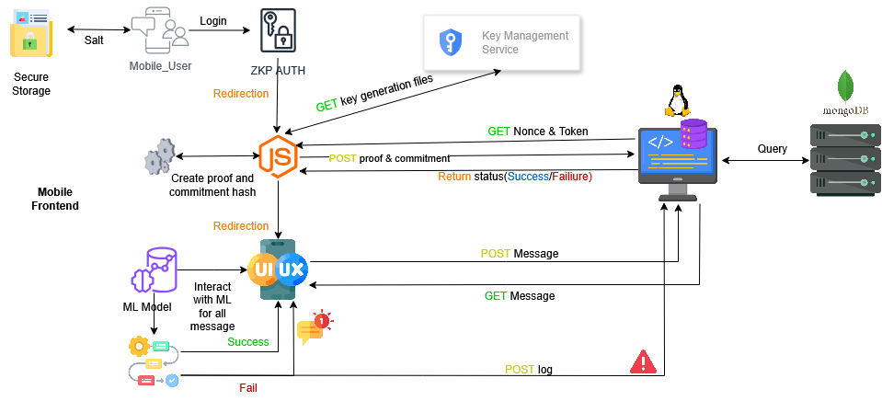
- System Architecture Design: The architecture is designed as a "Privacy-First" ecosystem. The diagram below illustrates the Client-Side processing, showing how the AI Engine sits before the Encryption Layer, ensuring the server only ever receives opaque, encrypted data.

Fig. 3.4.2.1 SentriZK System Architecture

- Component Interaction Diagrams: Three specific diagrams were designed to map the core functionalities:
  - ZKP Registration Sequence Diagram: A detailed sequence diagram illustrating the hybrid mobile-web workflow for secure user registration. It maps the generation of a temporary Mobile Access Token (MAT), the handoff to a web interface for computationally intensive ZKP proof generation, the server-side verification using the Verification Key (VK), and the secure return to the mobile application via deep linking.
  - E2EE Key Exchange Sequence: A diagram designing the flow of public key exchange and shared secret derivation (ECDH). It visualizes how ephemeral keys are generated and exchanged so that messages are fully encrypted before network transmission, ensuring the server never sees plaintext.

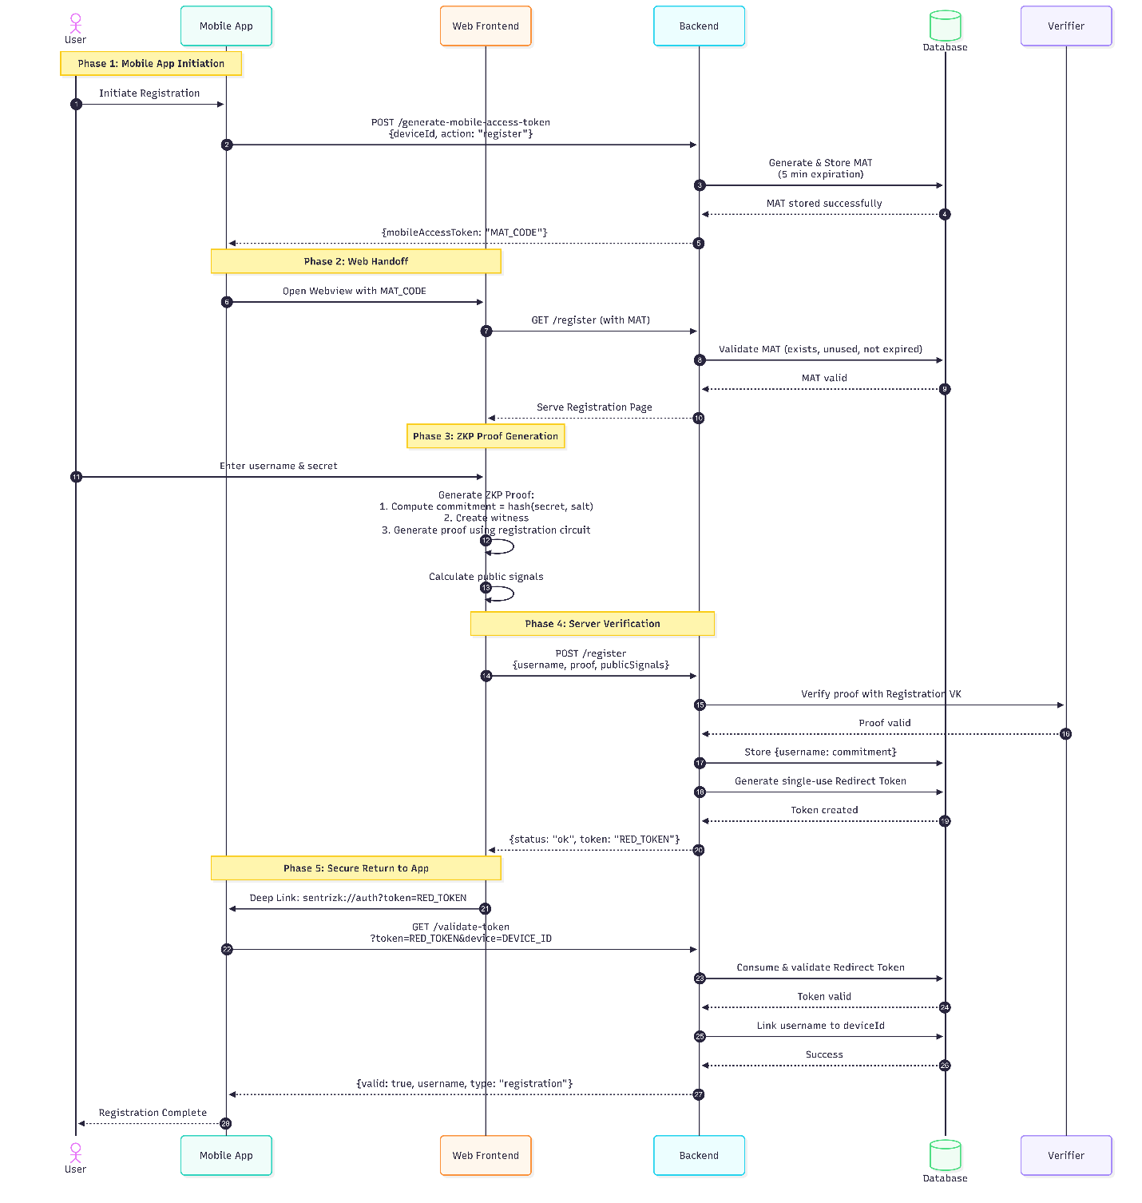

Fig. 3.4.2.2 SentriZK Sequence Diagram

- Process Flowchart: A high-level flowchart was designed to visualize the end-to-end operational logic between the Authentication, Sender, and Receiver entities. It delineates the system's decision-making process:
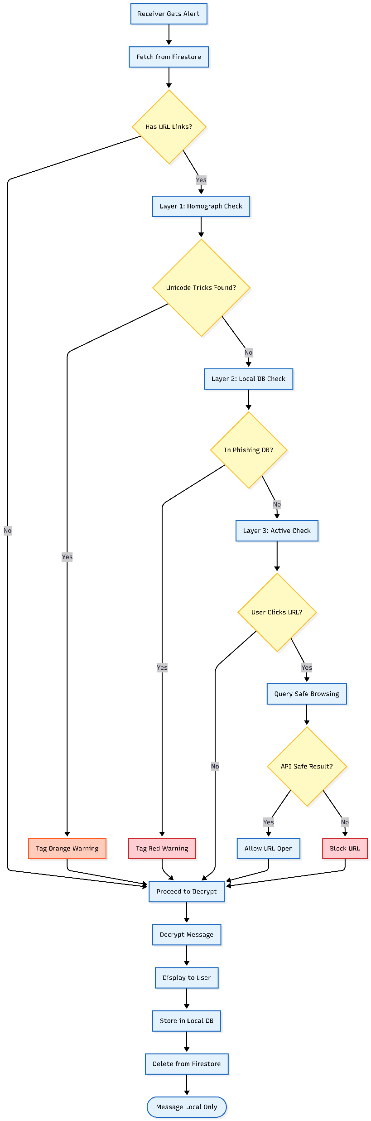
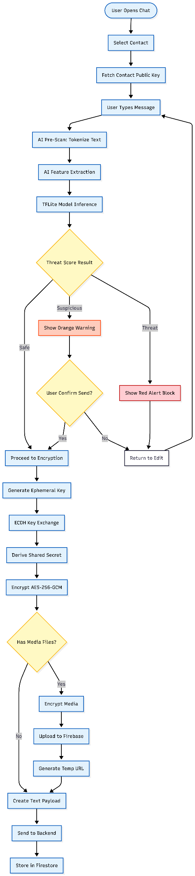
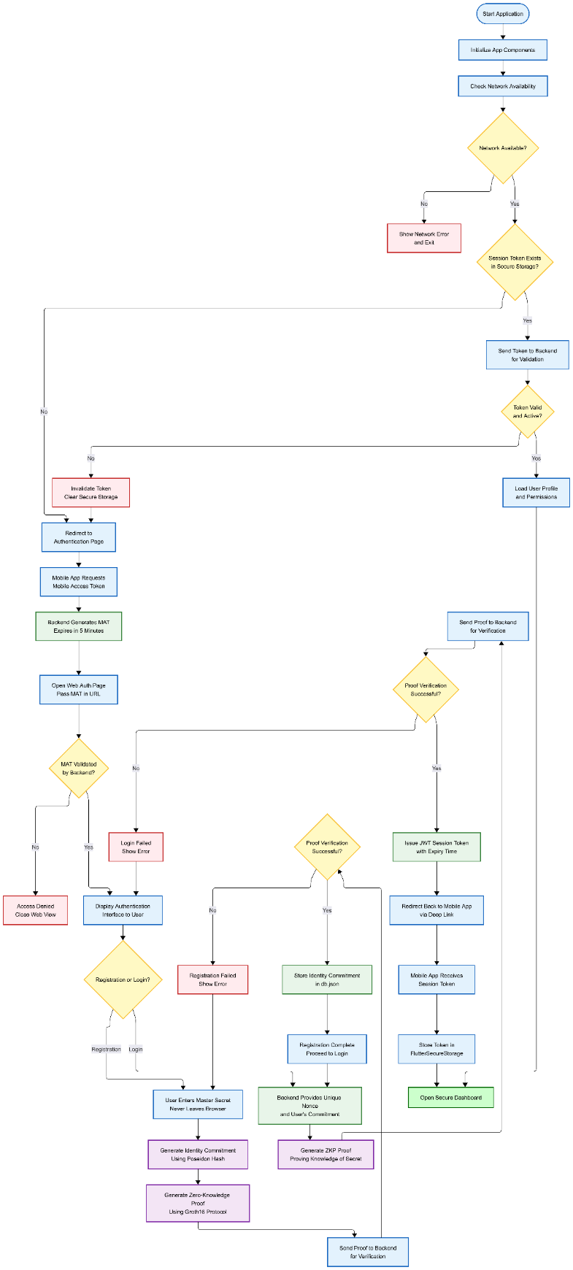

Fig. 3.4.2.3 SentriZK Flow chart
- Use Case Diagram: The Use Case diagram was designed to define the system's functional scope and actor interactions. It identifies the "SME Employee" as the primary actor and maps their engagement with the system's three core security modules

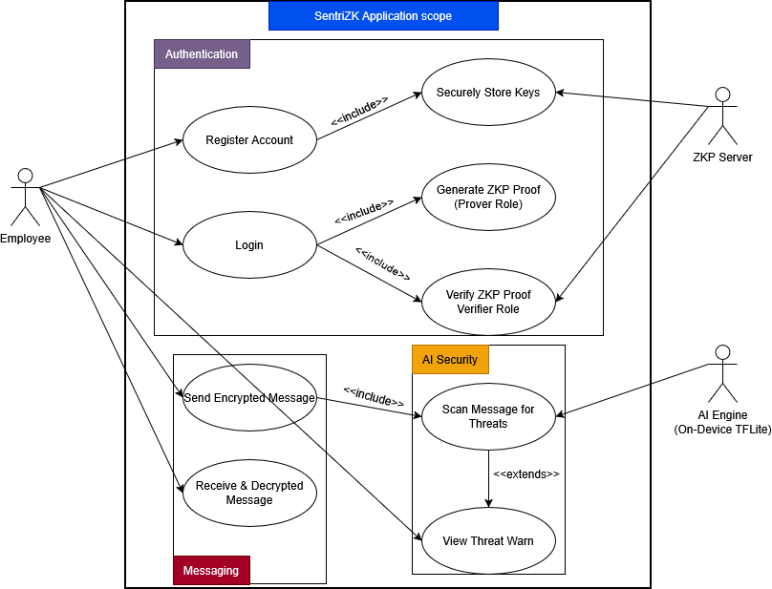

Fig. 3.4.2.4 SentriZK Use Case Diagram

- Threat Model Diagram The threat model for the application was expanded to address vulnerabilities at three critical layers: the Client, the Network, and the Server. The diagram visualizes the specific attack vectors the system is designed to neutralize
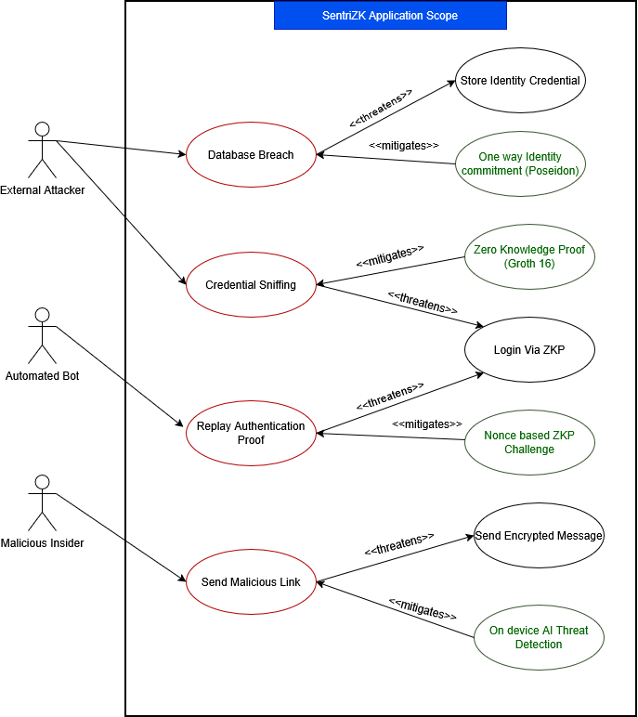
Fig. 3.4.2.5 SentriZK Misuse Case Diagram

3.4.3 Phase 3: Construction
This phase focused on the actual programming and integration of the system's three core modules. The development process was divided into specific tasks for authentication, encryption, and threat detection.

Module A: Zero Knowledge Authentication
The development of the authentication module began with writing custom cryptographic circuits using the Circom language. These circuits were designed to define the constraints for proving knowledge of a password without revealing it. Following the circuit design, a "Trusted Setup" (Powers of Tau) ceremony was conducted to generate the proving and verification keys required for the zk-SNARK protocol. Finally, the snarkjs library was integrated into the client application. This integration allowed the mobile app to generate mathematical proofs locally, enabling users to verify their identity to the server without ever transmitting their actual credentials.

Module B: End-to-End Encryption
For the messaging module, the application was programmed to enforce privacy by default. Upon user registration, the system automatically generates ephemeral key pairs using the Ed25519 elliptic curve. An AES-256-GCM encryption protocol was implemented using the crypto-js library to handle message payloads. The logic was programmed so that when User A sends a message to User B, the system first derives a shared secret locally on the device, encrypts the message payload, and only then sends the ciphertext to the server. To ensure the safety of these keys, the flutter_secure_storage library was utilized to store private keys within the hardware-backed Android KeyStore or iOS Keychain.

Module C: AI Anomaly Detection
The threat detection module involved training Machine Learning models to recognize security risks. An Isolation Forest and Autoencoder model were trained using gathered datasets containing patterns of social engineering and malicious URLs. Once trained, the models were optimized and converted into the TensorFlow Lite format, ensuring the file size remained under 10MB for efficient mobile performance. This optimized model was then embedded directly into the Flutter client. It was programmed to intercept user input in real-time, assigning a "Threat Score" to outgoing messages. If this score exceeds a predefined threshold, the system triggers a warning to the user before the message is encrypted and sent.

3.4.4 Phase 4: Cutover
The Cutover phase is the final step where the system transitions from a development build to a functional prototype ready for demonstration. This phase is scheduled to happen immediately after the construction phase is finished.

Integration Testing:
In this step, the three separate modules ZKP Authentication, E2EE, and AI will be combined into a single cohesive application. Rigorous testing will be conducted to ensure they work together smoothly. A major focus here is to verify that the on-device AI inference is fast enough; it must not introduce noticeable lag (latency) that would delay the encryption process or make the "Send" button feel unresponsive.

Security Audits:
A comprehensive security review is planned to validate that the system actually protects data as intended. This involves specific technical tests:
- Replay Attacks: Will attempt to capture an old login proof and send it to the server again to verify that the system's "nonce" mechanism correctly rejects the duplicate request.
- Simulated Database Breach: Will access the backend database directly to confirm that an attacker would only find useless ciphertext and mathematical commitments, proving that no readable user data is stored.
- AI Model Testing: The AI model will be tested against a fresh dataset of phishing links to calculate its detection accuracy and ensure it provides valid warnings.

User Acceptance Testing (UAT):
The final prototype will be presented to the staff at NISHA SUTERA ENTERPRISE. They will be asked to use the system in a controlled environment to perform their standard daily communication tasks. The objective is to verify that security measures specifically the AI threat warnings are helpful and do not intrude upon their daily operational workflow. The feedback collected from this session will be used to make any final adjustments to the interface or sensitivity settings before the project is concluded.

3.5 System Requirements

This section outlines the hardware and software resources utilized to develop and test the SentriZK system. Given the project's focus on "privacy-first" security, the technical setup required specific tools capable of handling cryptographic generation and on-device AI processing without relying on external cloud processing.

3.5.1 Hardware Requirements
The hardware selection was divided into high-performance development units and low-cost deployment units to demonstrate the system's feasibility for Small and Medium Enterprises (SMEs).

- Development Workstation (Lenovo Legion)
A high-specification laptop was required for the primary development phase. The inclusion of a dedicated GPU was essential for training the Isolation Forest AI models, a task that demands significant computational power. Furthermore, running the Android Studio emulator concurrently with the Node.js backend required a minimum of 16GB RAM to maintain a stable testing environment.
- Mobile Test Device (Physical Android Phone)
Although emulators were used for initial interface design, a physical Android device was necessary for final system verification. Real hardware was required to accurately test the camera performance for scanning ZKP QR codes and to assess the biometric authentication sensors. Testing on a physical device also provided critical data regarding battery consumption and heat generation during the AI inference process.
- Server Node (Raspberry Pi 5 - 8GB)
To avoid the recurring costs associated with cloud hosting services like AWS, a Raspberry Pi 5 was deployed as the primary server. This device hosts the backend API and database. The 8GB RAM model was selected to ensure sufficient memory for handling concurrent verification requests, demonstrating that the entire security architecture can run on accessible, low-cost hardware.

3.5.2 Software Requirements
The software stack consists of open-source tools selected for their security features and mobile compatibility.

- Flutter: This framework was selected for mobile development to ensure efficiency. It allowed for the creation of a single codebase that functions across various Android versions without requiring extensive native code adjustments.
- GetX: This library was utilized for state management, simplifying the data flow between the secure login screens and the encrypted chat interface.
- Next.js: A web-based interface was developed using Next.js to handle the computationally intensive ZKP key generation, which can be resource-heavy for older mobile devices.
- Node.js: The backend logic is built upon the Node.js runtime. It was chosen for its lightweight architecture and efficient handling of JSON data packets sent from the mobile client.
- Cloudflare Tunnel: To secure the local Raspberry Pi server without exposing it via risky router port forwarding, Cloudflare Tunnel was implemented. This service provides a secure, encrypted connection to the internet for external access.
- Firebase: This service is utilized strictly for "signaling" purposes—notifying a user that a message is waiting without storing the actual message content.
- TensorFlow Lite: The original Machine Learning models were converted into the TensorFlow Lite format. This optimization was necessary to reduce the file size, allowing the Isolation Forest model to run locally on the device for real-time threat detection.
- SnarkJS: This JavaScript library is integral to the system, handling the mathematical generation of Zero-Knowledge Proofs on the client side and verification on the server side.
- Hive DB: For local data storage, Hive DB was implemented due to its superior read/write speeds compared to traditional SQL databases, ensuring quick access to encrypted chat history.

3.5.3 Budget and Costing
The primary objective of this project was to demonstrate a cost-effective security solution for SMEs. By adopting a self-hosted architecture, the project successfully eliminated most recurring monthly subscription costs.
The table below categorizes the financial resources into "Assets" (existing equipment reused for the project) and "Expenditure" (actual funds utilized).
Item | Category | Cost (RM) | Description
Development Hardware
Lenovo Legion Laptop | Asset | 4,500.00 | Existing workstation used for coding and training.
Android Test Phone | Asset | 800.00 | Physical devices are used for hardware-level testing.
Server Infrastructure
Raspberry Pi 5 (8GB) | Asset | 400.00 | Self-hosted server node to eliminate cloud fees.
Software & Services
Cloudflare Tunnel | Service | 0.00 | Free Tier (Zero Trust) for secure remote access.
Firebase (Spark Plan) | Service | 0.00 | Free Tier is utilized for signaling only.
Project Expenditure
Domain Name (.com) | Cash Out | 80.00 | 1 year registration fee for the web identity.
TOTAL COST |  | RM 80.00 | Total actual cash expenditure.

Table 3.5.3.1: Project Cost Breakdown

3.6 Project Planning

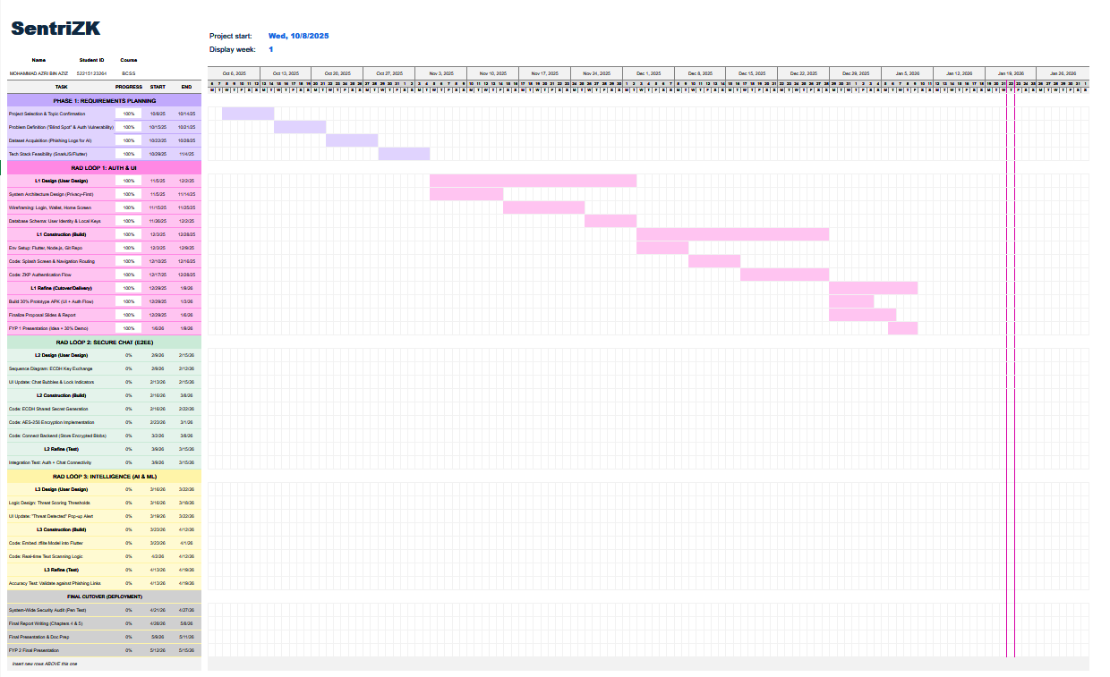
Gantt Chart Link: Excel_File_Link
Figure 3.6.1: Project Gantt Chart Summary

3.7 Chapter Summary
To conclude, this chapter explained the methodology and tools selected to develop the SentriZK project. The Rapid Application Development (RAD) model was chosen because it allows the three main security modules to be built and tested in cycles, rather than waiting for one massive phase to finish. The technical design was also mapped out using specific diagrams, such as the system architecture and threat model, to give a clear picture of how the "Privacy First" logic actually works.
Additionally, this chapter listed the required hardware and software, confirming that the project can be deployed on a tight budget using self-hosted tools like the Raspberry Pi. Now that the design and planning are clear, the next stage is the actual building of the system. The next chapter, Chapter 4: System Development, will document the practical steps taken to write the cryptographic code, train the AI models, and integrate everything into the mobile application.

REFERENCES

- Alatawi, M., & Saxena, N. (2023). SoK: An Analysis of End-to-End Encryption and Authentication Ceremonies in Secure Messaging Systems. 2023 IEEE Symposium on Security and Privacy (SP), 2816–2833. https://doi.org/10.1109/SP46215.2023.00158
- Barnes, R., Beurdouche, B., Robert, R., Millican, J., Omara, E., & Cohn-Gordon, K. (2023). The Messaging Layer Security (MLS) Protocol (RFC 9420). Internet Engineering Task Force (IETF). https://www.rfc-editor.org/rfc/rfc9420.html
- Bhattacharya, S., Seth, D., Panyam, S., & Gangrade, P. (2024).¹ Enhancing Digital Privacy: The Application of Zero-Knowledge Proofs in Authentication Systems. International Journal of Computer Trends and Technology, 72(4), 34-41.
- Bispo, G. D., Silva, L., & Souza, A. (2025). PHILDER: Lightweight Framework for Intelligent Phishing Detection on Resource-Limited Devices.² IEEE Internet of Things Journal, 12(4), 3421-3435.
- Chen, Z., Liu, Y., & Wang, H. (2023). A Survey on Zero-Knowledge Authentication for Internet of Things. Electronics, 12(9), 2098.
- Gaurav, A., Gupta, B. B., & Panigrahi, P. K. (2025). AI-Driven Smishing Detection in Android Devices Using TinyBERT and Aquila Optimization. Neural Computing and Applications, 37, 1245–1258.
- Hussain, S., & Ali, M. (2023). Phishing Detection System Through Hybrid Machine Learning Based on URL. 2023 International Conference on Computing, Electronics & Communications Engineering (iCCECE), 112-117.
- Ilesanmi, M. (2025). Threat Modeling for Enterprise Secure Messaging Applications. Journal of Cybersecurity, 9(1), tyad004.
- Luong, D. A., & Park, J. H. (2023). Privacy-Preserving Identity Management System on Blockchain Using zk-SNARK. IEEE Access, 11, 1840-1853.³
- Mishra, P., & Gupta, A. (2025). A Secure Framework for Privacy-Preserving Analytics in Healthcare Records Using Zero-Knowledge Proofs. Future Generation Computer Systems, 158, 201-214.
- Natha, S., Al-Zahrani, A., & Al-Ghamdi, A. (2022). A Systematic Review of Anomaly Detection Using Machine and Deep Learning Techniques. Journal of King Saud University - Computer and Information Sciences, 34(9), 7483-7498.
- Patel, R., & Singh, V. (2025). Implementation of Secure E2EE Chat Application in Microservice Architecture. MDPI Applied Sciences, 15(3), 1204.
- Rahman, F., & Lee, K. (2024). A Review of Recent Advances, Challenges, and Opportunities in Malicious Insider Threat Detection Using Machine Learning Methods. IEEE Access, 12, 15432-15455.
- Srinivasan, K., Chauhan, G. S., & Almahdi, M. (2025).⁴ Insider Threat Detection and Secure Data Transfer Leveraging Bidirectional LSTM. International Journal of Digital Innovation and Discoveries, 1(1), 15-21.⁵

